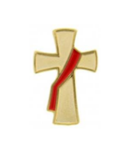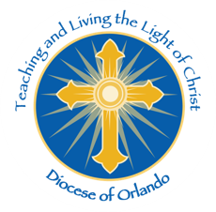

OFFICE OF THE

PERMANENT DIACONATE

From the:

“I urge you to live in a manner worthy of the call you have received.” (Eph 4:1)

**ADMINISTRATIVE**

Deacon Annual Documents

Effective July 1, 2018 Deacons who have not submitted their annual documents will **NOT** be considered to be in “Good Standing”.

***Required Documents:***

1. Statement of Mutual Expectations & Pastor Assessment,
2. Continuing Formation Form, &
3. Review and submit changes to your Funeral Arrangements Form.

So what does it mean when you are not in good standing? Rest assured these deacons will still have faculties to serve within the Diocese of Orlando, however, if you request a letter of good standing to serve outside the diocese (i.e. relocation, marriages, baptisms, funerals, serving while on travel, etc…) will not be approved.

All ‘Active’, ‘Retired’ & ‘Senior’ deacons, currently with faculties are required to submit these documents annually to remain a deacon in ‘good standing’. Seasonal deacon need to work with their home diocese to retain their faculties.

**All the forms are on the** [**Deacon Webpage**](https://www.orlandodiocese.org/ministries-offices/deacons-welcome/104435-2/) in English & Spanish. They are regularly updated as we work to ensure clarity in what is required. There will be a new revision to the Continuing Formation Form uploaded in July that more precisely defines a “credit hour” for each session of the form.

**NOTE:** *Those completing the forms in Spanish must have them translated to English prior to submitting to the Office of the Permanent Diaconate.*

Deacon Title. As I have traveled the diocese and collected church bulletins we’ve noticed a variety of titles used for a permanent deacon (i.e. Rev. Mr.; Rev.; Senior Deacon). For the Diocese of Orlando the proper title for a permanent deacon is “Deacon”. “Senior Deacon” is not a title, it is a classification meaning you reach mandatory retirement age, yet are still active in the parish.

Please work to correct any discrepancies in your parish bulletins & webpages.

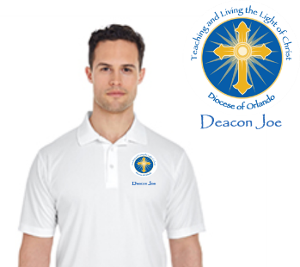Diocesan Shirts

Some have noticed the diocesan logo shirts the men in formation are now sporting and have asked if they could get one or two. We are happy to announce we are making them available.

Shirts must be ordered via this office to ensure branding requirements are maintained. Shirt cost is $24.00 for S-XL (there is an up charge of $2.00 for each size over XL; i.e. XXL= $24 + $2; XXXL= $24 + $4; etc…)

Colors available to order include:

|  |  |  |  |  |  |  |  |  |
| --- | --- | --- | --- | --- | --- | --- | --- | --- |
|  |  |  |  |  |  |  |  |  |
| White |  | Red |  | Purple |  | Green |  | Black |

**CONTINUING FORMATION**

Continuing Formation Form.

So we mentioned earlier, effective July 1 there will be a revised Continuing Formation Form available on the Deacon’s Webpage. The new form outlines how to calculate formation credit hours. Below is a summary of how to earn credit hours in Section B:

1. Retreats: must include your required canonically required overnight retreat. Earn 1 credit hour/day
2. Courses, Seminars, Workshops, Conventions, Conferences, Days of Reflections. Earn 1 credit hour/day or event if less than a day.
3. Books, Tapes/CD’s, Religious Movies. Earn 1 credit hour/title.
4. Articles written for church associated publications. Earn 1 credit hour/article.
5. Other Continuing Education Activities. This line item is used to document any activity you perform in your official diaconate ministry. Presider at weddings (prep & ceremony), funerals (wake & internment), baptisms, communion service, exposition/benediction; presenter of workshops, Spiritual direction, etc… Earn 1 credit hour/day or event if less than a day.
6. Number of Region/Deanery Meetings Attended. Earn 1 credit hour/meeting.

***Did You Know?***

1. You can request to sit in on the Diaconate Formation classes? Each class/workshop can earn you continuing formation 1 credit hour for each day of attendance.
2. FORMED is an excellent and convenient form of gaining formation credit hours (1 credit hour for each program).

Local opportunities abound for continuing formation. We share these opportunities via email, facebook, and the diocesan webpage. If your parish is sponsoring an event let us know and we will pass the Word.

**LITURGICAL CORNER**

We are still looking for a Monstrance w/matching Luna for a poor parish in Panama. If your parish has plans to order a new monstrance and is willing to donate the old one to this Panama parish please inform our office.

EMHC Mandate Renewals. The following link: [EMHC Mandates](https://www.orlandodiocese.org/ministries-offices/liturgy-music-welcome/liturgy-music-emhc-training/), outlines the requirements for “New” and “Renewal” of mandates and related paperwork.

* As deacons we can be presenters for the recommended annual Days of Eucharistic Reflections to facilitate mandate renewals.
* For NEW EMHC’s the training curriculum and trainers are managed by the diocese office of Liturgy and Music. If you are interested in being a certified trainer for these sessions you must be vetted and approved by the Office of Liturgy and Music.

An issue surfacing for some EMHC around the diocese are that their mandate expired. Mandates are good for 5 years. If the EMHC’s mandate expires, they must take the diocesan workshop.

Renewals can be quite simple. The parish hosts scheduled annual days of reflection on the Eucharist, completes the forms, the pastor approves the renewal, and the complete renewal form is sent to the Office of Liturgy and Music.

Liturgical Movements. Our liturgical presence, movement, and gestures mean a lot to the Liturgy.

Deacons serving in Choir.

* When deacons attend in mass for a celebration (i.e. ordination, funeral, chrism Mass) the deacons in the pews liturgical movements of the laity. Specifically, during the consecration, we kneel & stand with the parish community. The deacons on the altar are the only ones who kneel and stand at the appropriate time during the epiclesis.
* As a reminder, we remain standing after the Proclamation of the Gospel until the Bishop reverences the book and potentially blesses the congregation with the book.
* When there is to be incensing. The presider is incensed first, then the priest stand to be incensed (deacons should NOT stand at this time) and then the congregation is incensed, this is when the deacons stand.
* For the recessional, the clergy (priests and deacons) will be staged and we bow with the Bishop. We do not bow or reverence the altar a second time on the way out.

Liturgy of the Hours. At our ordination we promised to pray the liturgy of the hours daily, at least morning and evening prayers. As we participate in deanery meetings that start with this prayer, a couple things have caught our attention:

1. The prayer does not start by signing ourselves “In the name of the Father…” We sign ourselves as we say, “God come to my assistance…”
2. The intercessions are always interesting as we seemed to have been trained differently based on our formation year group, region and diocese. The norm is the presider recites the beginning of the intercession, at the red dash the assembled group reads. Repetition of the italic response is optional, follow along with the community.

Funerals. As the casket of our dear deceased brother is being prepared to be loaded into the hearse the clergy (priest and deacon) sign the Salve Regina. This has been a challenge to the ears. We encourage all of us to make a more concerted effort to learn the song so that we can send our brothers to rest in peace in beautiful harmony.

A side note, the men in formation are singing the Salve Regina after every evening prayer. It is our hope it will stick once they are ordained and begin to participate in our liturgies.

**OUTSIDE OF THE WALLS**

**FORMATION**

Ordination. On June 9, Bishop Noonan ordained eight devoted men to the Order of Deacon at the Basilica of the National Shrine of Mary, Queen of the Universe:

[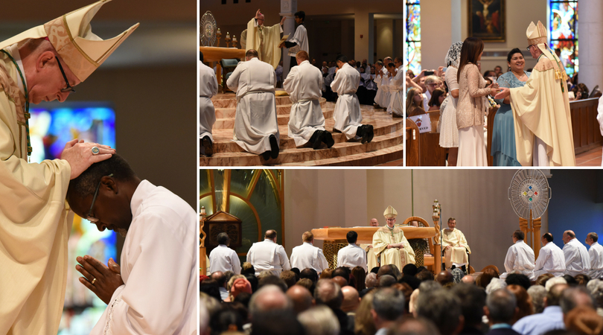](https://urldefense.proofpoint.com/v2/url?u=https-3A__orlandodiocese.us12.list-2Dmanage.com_track_click-3Fu-3D6157e0ca4f7bc625a8981aabf-26id-3D68a60e5476-26e-3D9a7785343c&d=DwMFaQ&c=euGZstcaTDllvimEN8b7jXrwqOf-v5A_CdpgnVfiiMM&r=3ryGa9mgOKsyLW1ds0aEYZzh1i4JBhPQAnf0rdmo2_Q&m=-6SD9UEeQifD5fEpyeTPLKLWmBe0itp9tb1NRN8Nd6I&s=89NNfg5FMOuzf19NwUNVaXqXFOAqsvbpT1ZvZawGPp8&e=)

*Picture is a hyperlink to the photo gallery*

These men and their families have journeyed together for many years and entered into a deeper relationship with God to ultimately respond Yes to the call to Ordination as a Permanent Deacon of the Catholic Church.

“For many years your parishes have prayed for you and now you are about to be ordained deacons. Today we will pray that God will bless you in your ministry of service to God and his people,” said Bishop Noonan. “May we always model ourselves after Jesus the Good Shepherd Who came not to be served, but to serve.”

The entire ordination can be viewed on facebook/Diocese of Orlando Deacons.

Curriculum Development Team & Retreats Committee

**FORMATION PROGRAM**. The Curriculum Review Workshop will be held July 14th from 9:00 a.m. to 3:00 p.m. All trainers have been invited and others who have expressed interested in assisting the continued process of improvement of the formation curriculum. To reserve a spot on the team: [jgassman@orlandodiocese.org](mailto:jgassman@orlandodiocese.org). Include a brief biography on your training/curriculum development experience.

Applicants (Cohort 2024)

Statistical Summary

* 77 men inquired about the permanent diaconate
* 62 applications were requested by pastors
  + 17 individuals choose not to submit an application
* 45 applications were received
  + 16 were withdrawn for various reasons during application reviews

Interview Team is comprised of:

* Deacon Joe & Judy Gassman
* Deacon Rick & Debbie Chabot
* Deacon Dave Gray
* Deacon John Rumplasch
* Deacon Eddie & Mariela Cruz
* Deacon Jose Class
* 4 applicant were recommended for non-selection.

25 applicants have been recommended to the Bishop to be invited into the Discernment year. Official notifications will be out by July 1, 2018.

Deacon Mentors. We are in need of deacon mentors. We would like to keep the one-on-one, Mentor, Mentee ratio as we find it most beneficial for both the mentor and mentee.

We are willing to travel to the deaneries to do the Mentorship Workshop. If you are interested in hosting a mentor workshop for your deanery please contact me to schedule a date.

If you are interested in becoming a deacon mentor you must be a:

* Active Deacon in Good Standing,
* Deacon for at least three (3) years *(Exceptions made on a case-by-case basis)*,
* Serving ministry in and outside the walls of the Church, and
* Willing to fulfill all the requirements of the Deacon Mentor Program.
  + Meeting Mentee at least once a month,
  + Meeting the Mentee and Wife at least quarterly,
  + Prepare and submit the monthly mentor report, and
  + Prepare and submit the annual recommendation for continued formation & ordination.

**UPCOMING EVENTS**

***Mark Your Calendars***

**2018 DIACONATE CONGRESS.** Will be on **July 22-26, 2018** in New Orleans. Representing the Diocese of Orlando we have 7 Deacons, 5 Wives and 1 Widow registered. If you would like more information or would like to register go to [www.Deacon2018.org](http://www.Deacon2018.org). They have opened an additional hotel to accommodate more participants.

**2018 CONVOCATION.** Will be on **October 6, 2018** @ St. Mary Magdalen Catholic Church, Altamonte Springs.

Mass with the Rite of Lector (Cohort 2020) @ 8:00 a.m.

**Bishop John Noonan presiding**

**Keynote Speaker: Deacon William T. Ditewig**

**2019 DEACON RETREATS.**

Will be held at San Pedro Center on the following weekends:

* February 1 – 3, 2019
* March 1 – 3, 2019
* April 5 – 7, 2019

**For a complete list of calendar of events visit the** [**Deacon Webpage**](https://www.orlandodiocese.org/ministries-offices/deacons-welcome/)**.**

**QUESTIONS?** If you have particular questions you would like to see addressed by this office, you may email your question(s) to [jgassman@orlandodiocese.org](mailto:jgassman@orlandodiocese.org).

“I have much more to tell you, but you cannot bear it now.”

(Jn 16:12)